NAPE ABUJA CHAPTER 2026 FIRST QUARTER REPORT

INTRODUCTION
The Nigerian Association of Petroleum Explorationists (NAPE) Abuja Chapter continued to demonstrate strong commitment to professional development, knowledge sharing, and strategic engagement in the first quarter of 2026. Through a series of well-curated programmes, the Chapter delivered impactful activities spanning technical capacity building, academic collaboration, youth engagement, and thought leadership within the geoscience and energy community.
These activities were largely conducted in hybrid formats, ensuring broader participation from members across different locations, while also strengthening in-person engagement within Abuja and the wider Northern region.
Key highlights of the quarter include technical business meetings addressing emerging industry trends such as GIS applications and machine learning in seismic interpretation, a hands-on capacity development workshop hosted in IBB Lapai, Niger State, a strategic virtual session on well cost optimization, and the successful delivery of the “Catch Them Young” outreach programme and collaborated with the National YP Team to host a podcast session on “The Employability Equation: What Actually Gets You Hired in the Oil and Gas Industry,” which attracted strong participation and ongoing engagement. The Chapter also hosted the landmark Rahaman 5.0 event in celebration of Prof. Omar Rahaman’s 80th birthday, reflecting on his legacy and contributions to African geoscience.
Overall, the quarter recorded strong participation from industry professionals, academia, students, and stakeholders, reinforcing the Abuja Chapter’s role as a hub for knowledge exchange, professional growth, and strategic engagement within NAPE.

JANUARY 2026

Catch Them Young Outreach – Community Secondary School, Asokoro
Date: 29th January 2026
Venue: Community Secondary School (CSS), Asokoro, Abuja
Mode: Physical
Attendance: ~200 participants
Sponsor: NAPE Abuja Chapter
Chairman: School Principal
Summary:
The Abuja Chapter conducted a career sensitization outreach aimed at inspiring secondary school students to pursue careers in geoscience and the energy sector. Students were introduced to career pathways and relevant subject combinations. Educational materials were distributed, and the session recorded strong engagement and interest.
Key Outcome: Increased awareness and early interest in geology and geoscience careers.

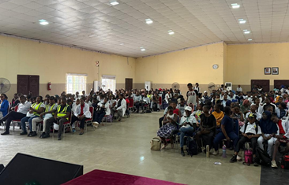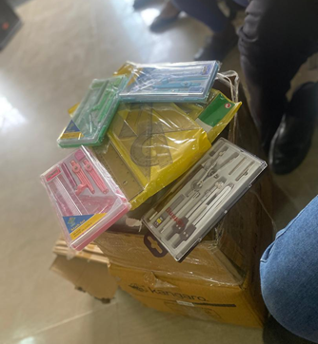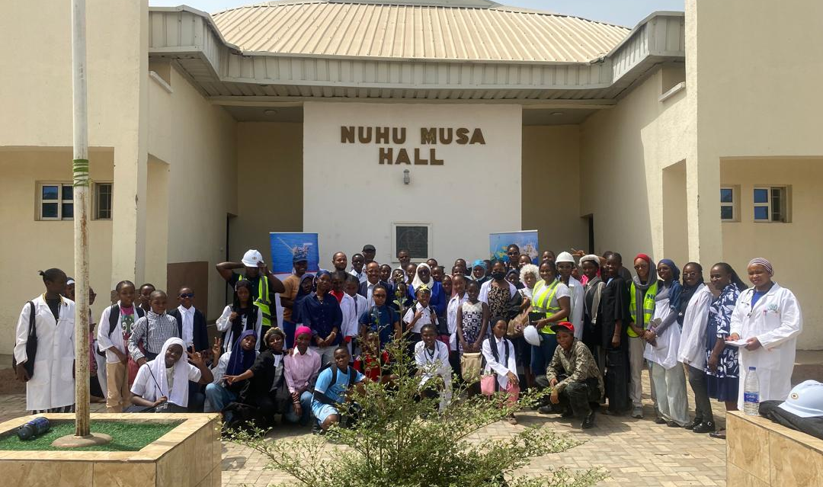

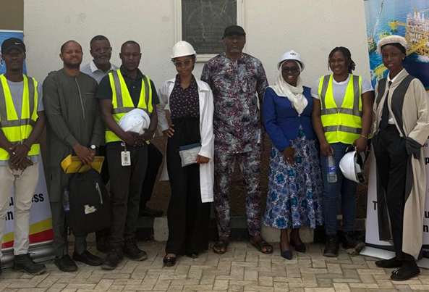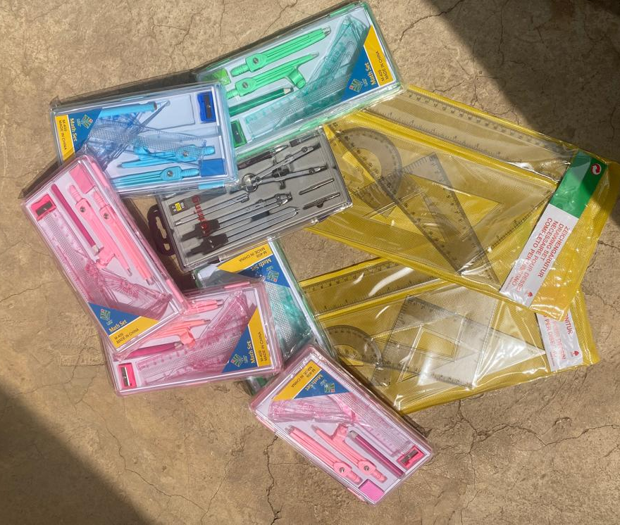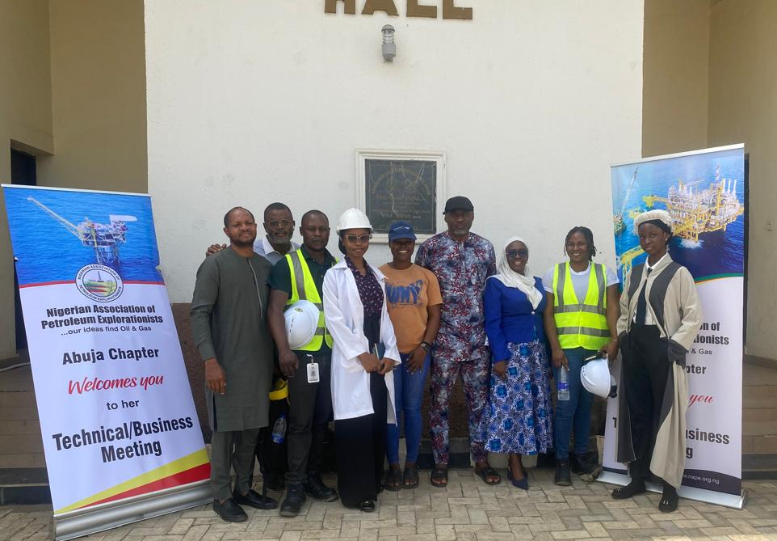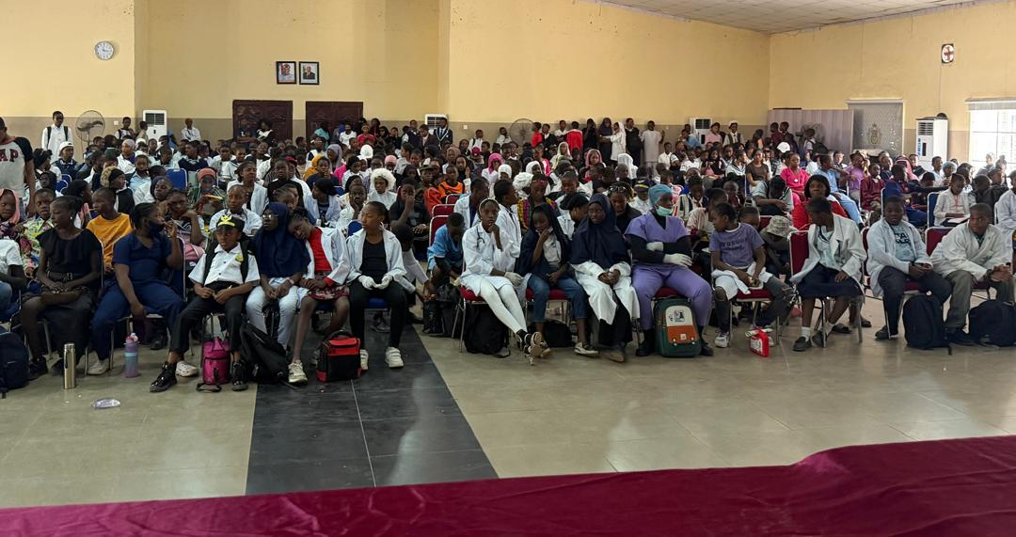

FEBRUARY 2026

Technical Business Meeting – Morphodynamics of Niger Delta Deposits
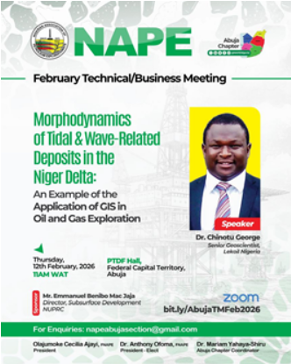
Date: 12th February 2026
Venue: PTDF Towers, Abuja

Mode: Hybrid
Attendance: ~120 participants
Sponsor: Emmanuel Mac-Jaja (NUPRC)
Chairman: Dr. Mohamed Malah
Summary:
The meeting focused on the application of GIS in understanding deltaic systems and reclassifying the Niger Delta. Discussions emphasized integrating seismic data to improve exploration outcomes.
Key Outcome: Enhanced understanding of delta systems and reservoir modelling.
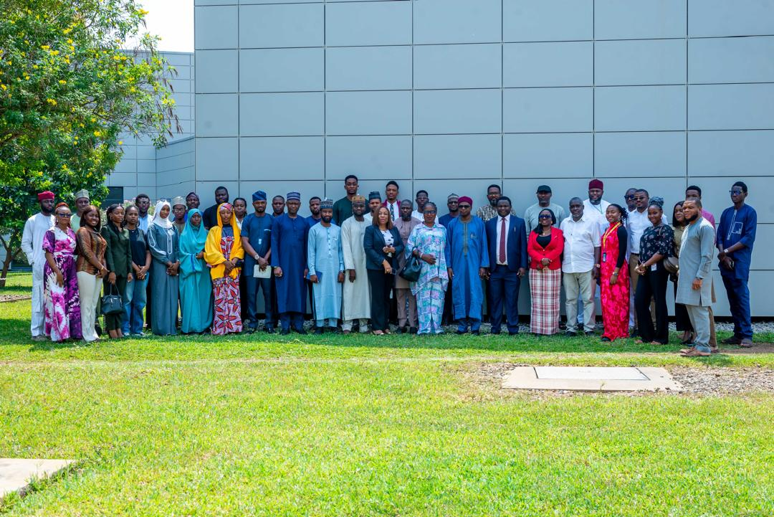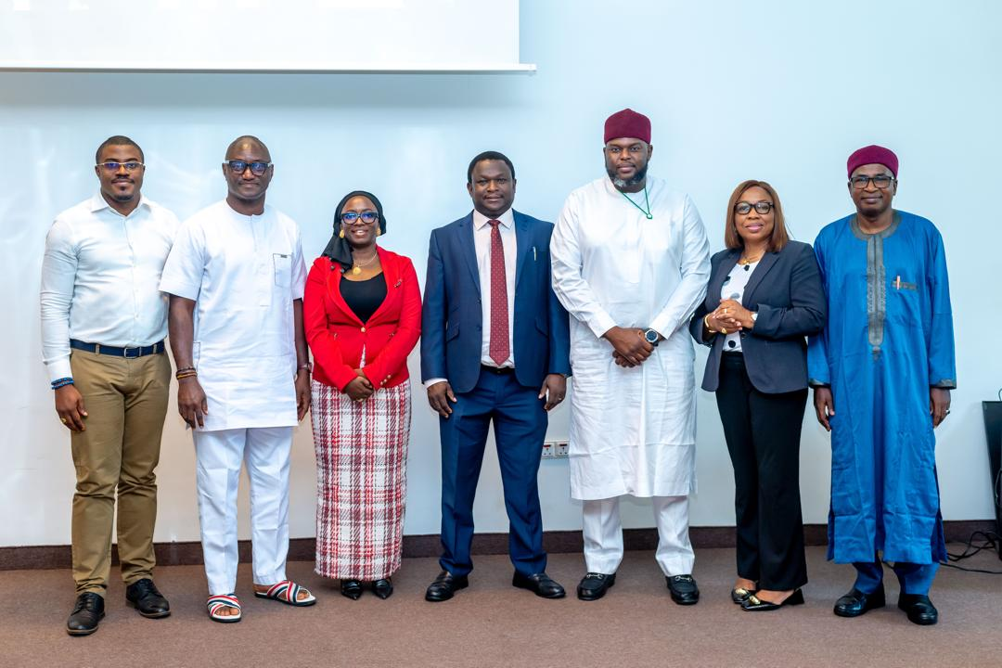
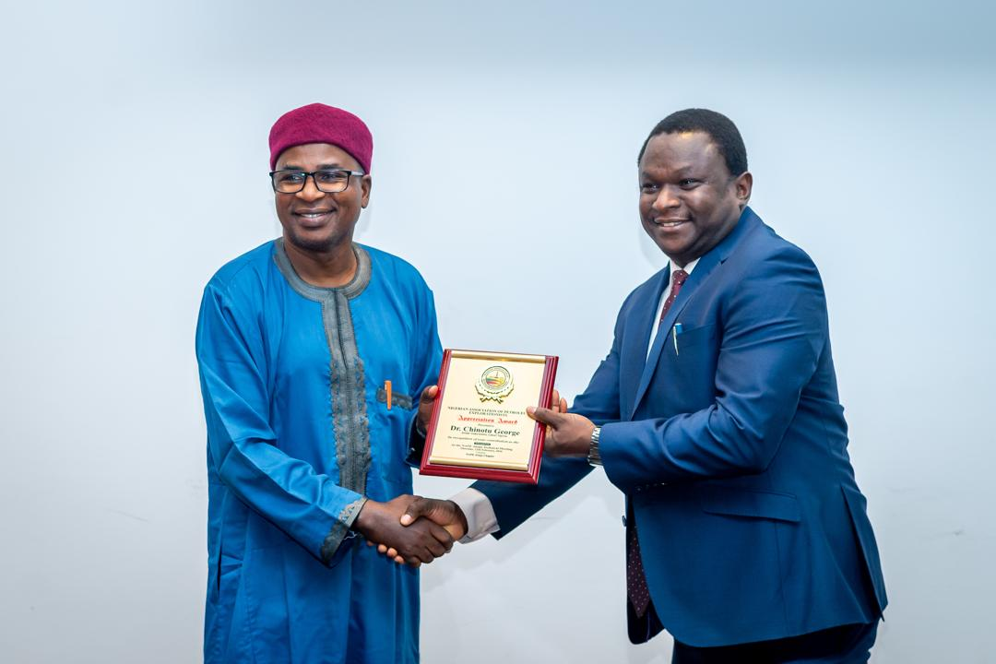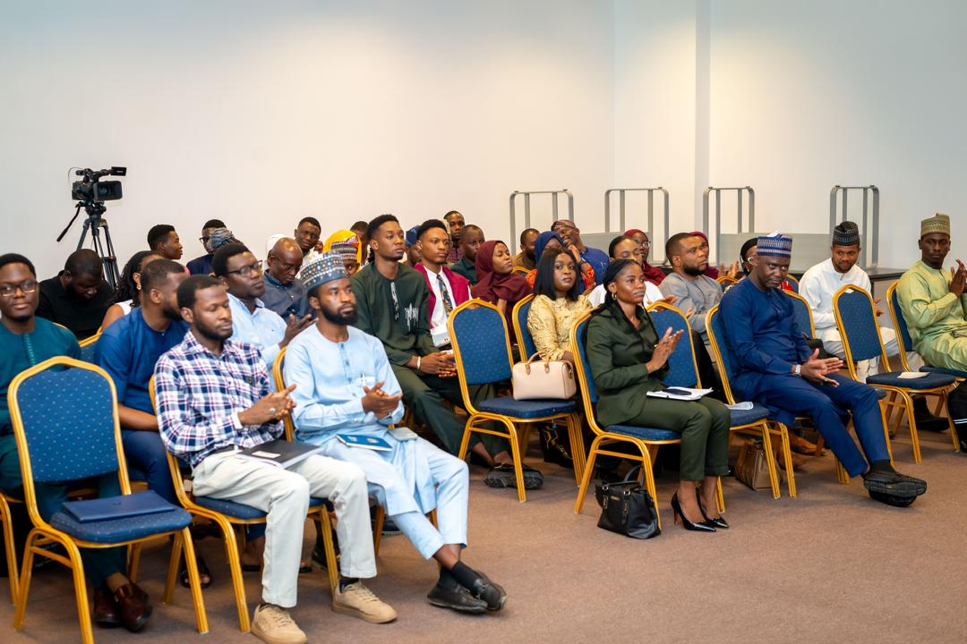

Two-Day Workshop – Well-log and Seismic Interpretation

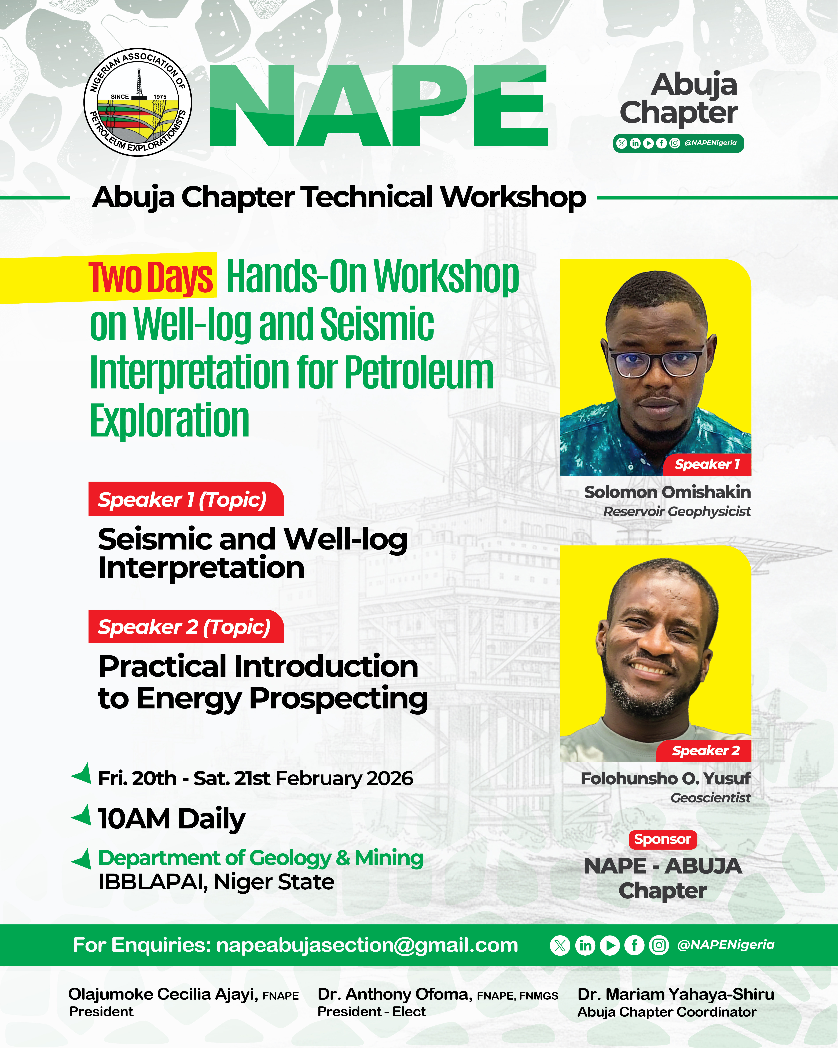
Date: 20th – 21st February 2026
Venue: IBB University, Lapai
Mode: Hybrid
Attendance: ~60 participants
Sponsor: NAPE Abuja Chapter
Chairman: Prof. Hadi Mohammed Suleiman, Vice Chancellor IBB Lapai
Facilitators: Solomon Omishakin; Folohunsho Olatunji Yusuf
Summary:
A hands-on technical workshop focused on seismic and well-log interpretation, bringing together students and professionals for capacity development and regional inclusion.
Key Outcome: Strengthened technical capacity and northern region engagement.

MARCH 2026
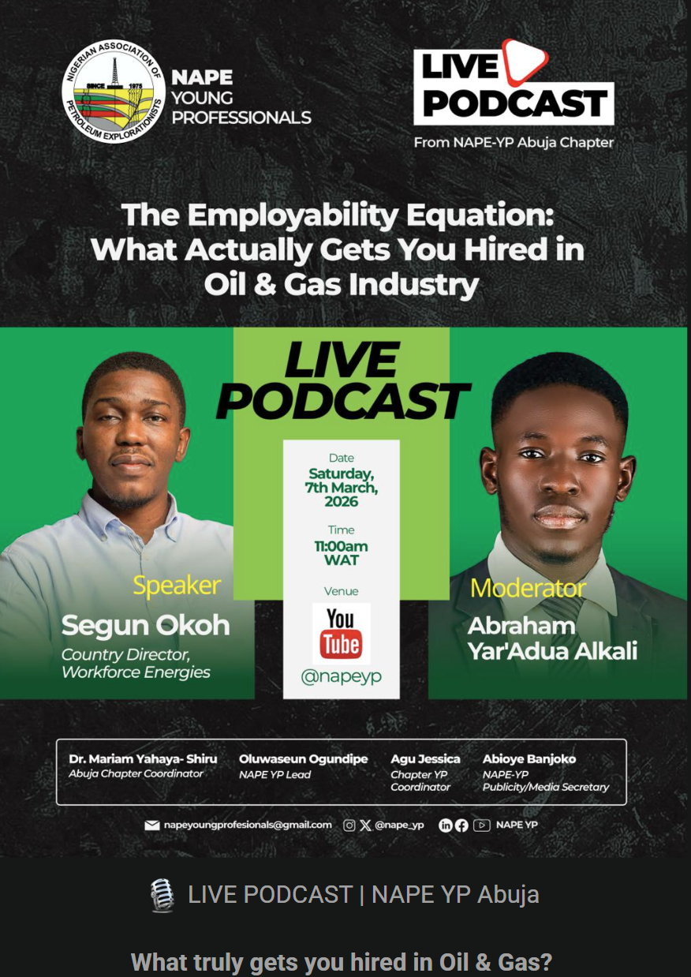
- Podcast Session – The Employability Equation
Title: The Employability Equation: What Actually Gets You Hired in the Oil and Gas Industry
Date: 7th March 2026
Mode: Virtual
Attendance: ~100+ participants; 383 viewers
Collaboration: NAPE National Young Professionals
Speaker: Segun Okoh (Country Director, Workforce Energies)
Moderator: Abraham Yaradya Alkali
Summary:
The Abuja Chapter, in collaboration with the National Young Professionals, hosted a virtual podcast session focused on career readiness and employability within the oil and gas industry.
The session provided practical insights into the skills, competencies, and strategies required to secure opportunities in a highly competitive industry. It featured strong participation, with over 100 attendees and highly engaging discussions driven by insightful questions from participants.
As of date, the podcast has recorded approximately 338 views, reflecting continued interest and relevance among young professionals.
Key Outcome: Enhanced awareness of industry expectations and practical guidance for improving employability among early-career professionals.

Technical Business Meeting – Applied Machine Learning for Seismic Interpretation
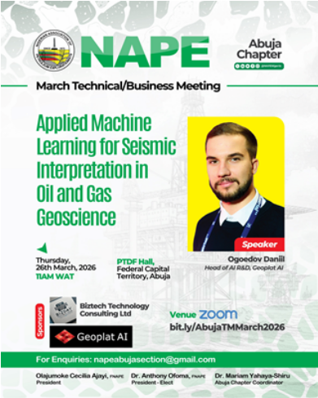

Date: 26th March 2026
Mode: Hybrid
Attendance: ~160 participants (Online and Physical)
Sponsor: Biztech Technology Consulting Ltd
Chairman: Emmanuel Egbele (represented National President)
Speaker: Bogoedov Daniil
Summary:
The session explored AI and machine learning applications in seismic interpretation, highlighting practical tools for improving data quality and decision-making.
Key Outcome: Increased awareness of AI-driven geoscience solutions.

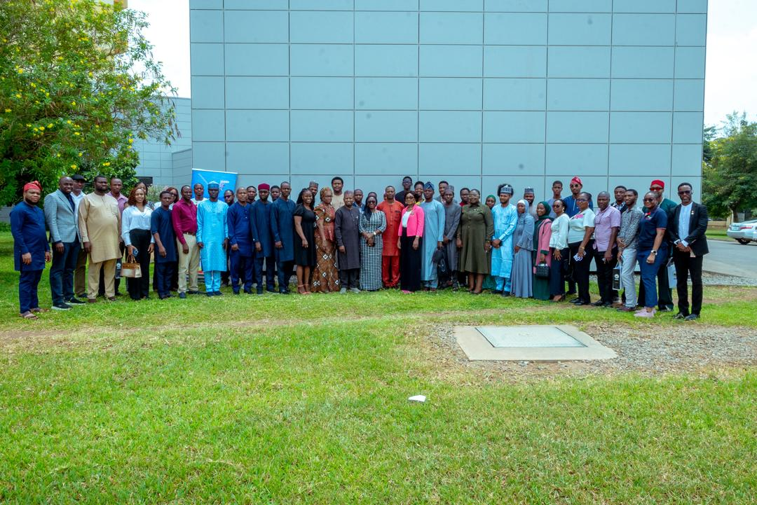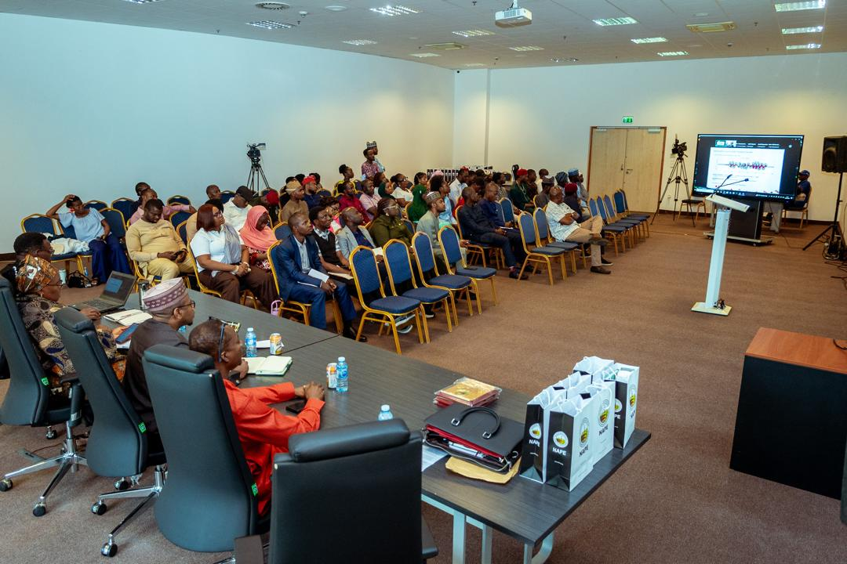

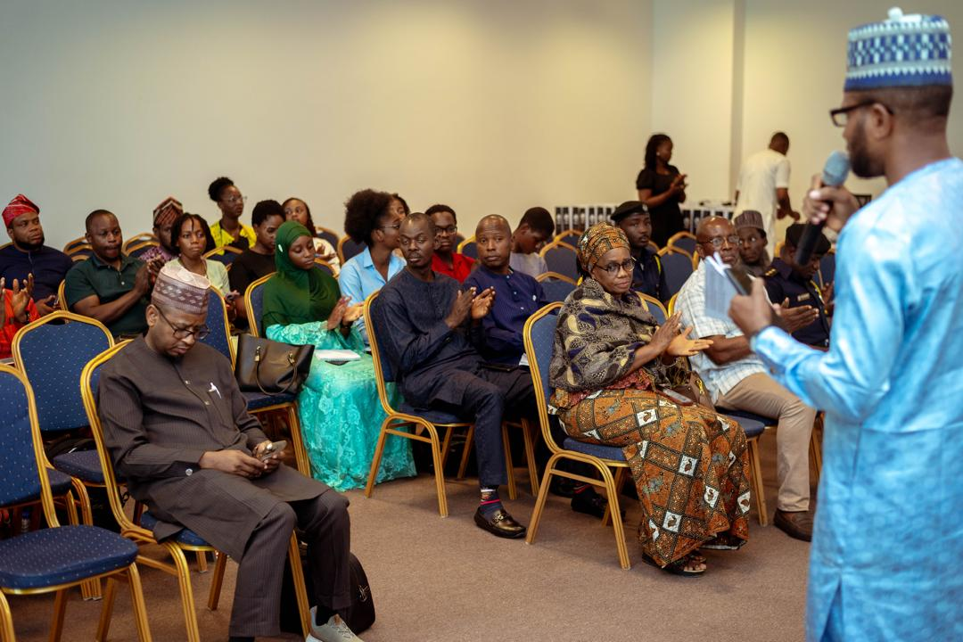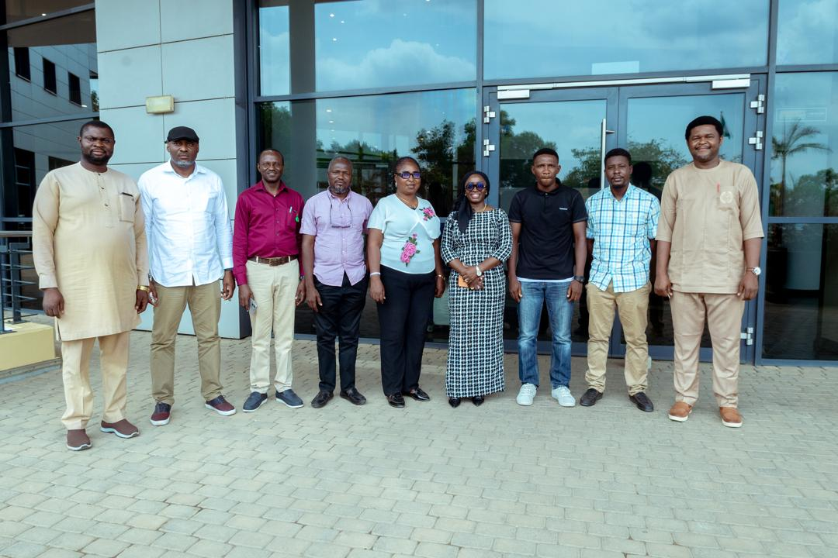

APRIL 2026

Virtual Technical Meeting – Early Well Cost Prediction Framework
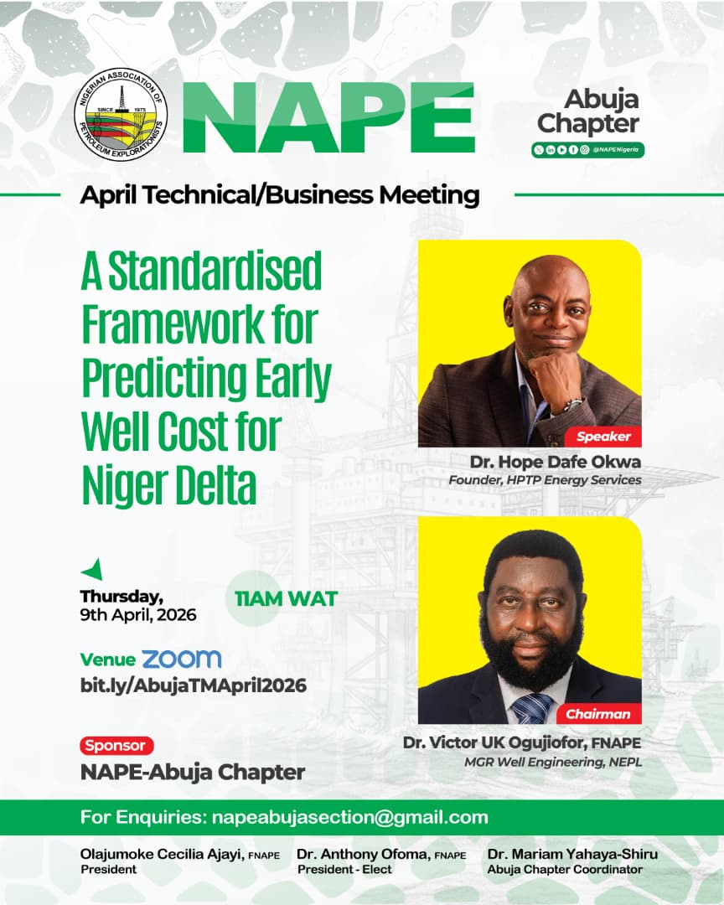

Date: 9th April 2026
Mode: Virtual
Attendance: ~160+ participants (Physical and virtual)
Chairman: Dr. Victor U.K. Ogujiofor, NEPL
Summary:
The meeting focused on standardized frameworks for predicting well costs in the Niger Delta, improving planning and cost efficiency.
Key Outcome: Improved understanding of cost optimization strategies.

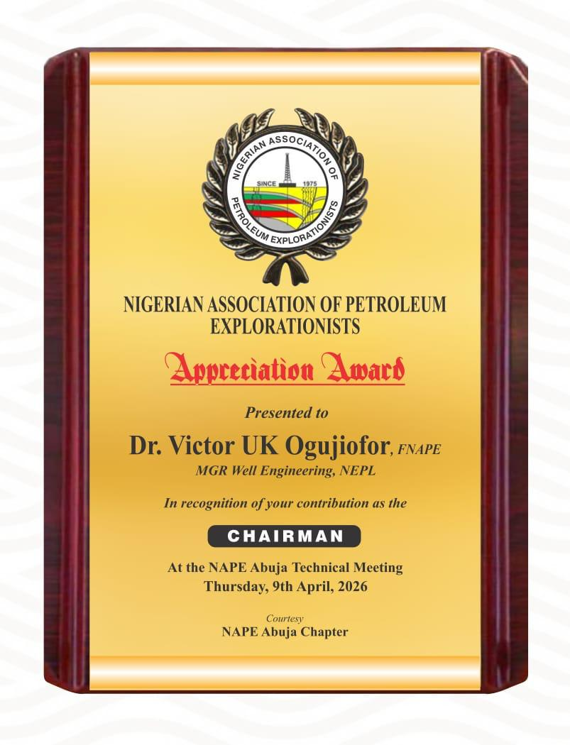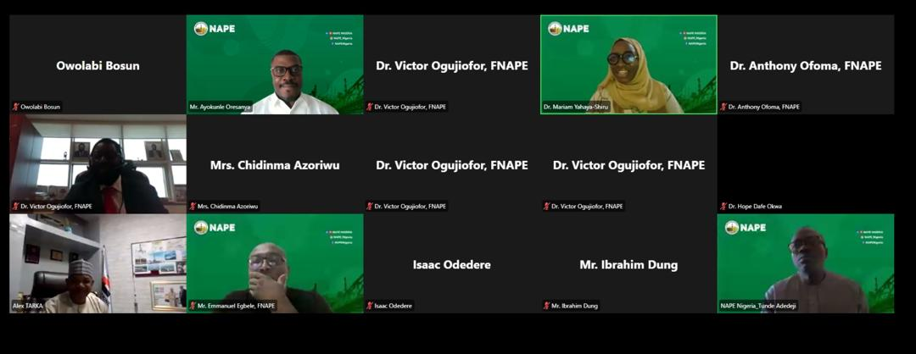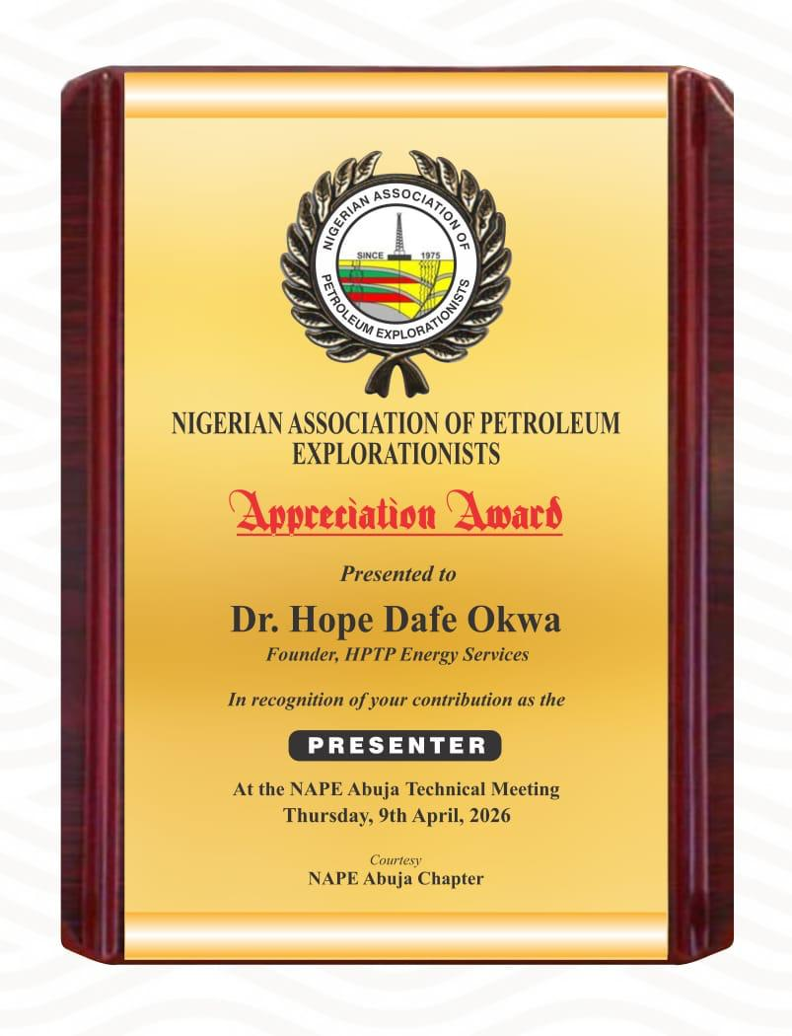

Rahaman 5.0 – 80th Birthday Anniversary Celebration
Date: 18th April 2026
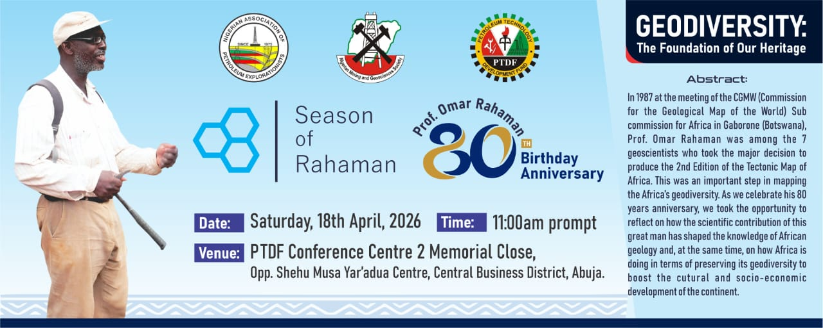
Mode: Hybrid
Attendance: ~150 participants (physical and virtual)
Chairman: Dr. Kehind Ladipo
Key Speaker: Prof. S. Felix Totteu
Summary:
A landmark event celebrating Prof. Omar Rahaman’s contributions to African geoscience. The keynote lecture focused on geodiversity and its importance to sustainable development.
Key Outcome: Recognition of legacy and advancement of geoscience discourse in Africa.

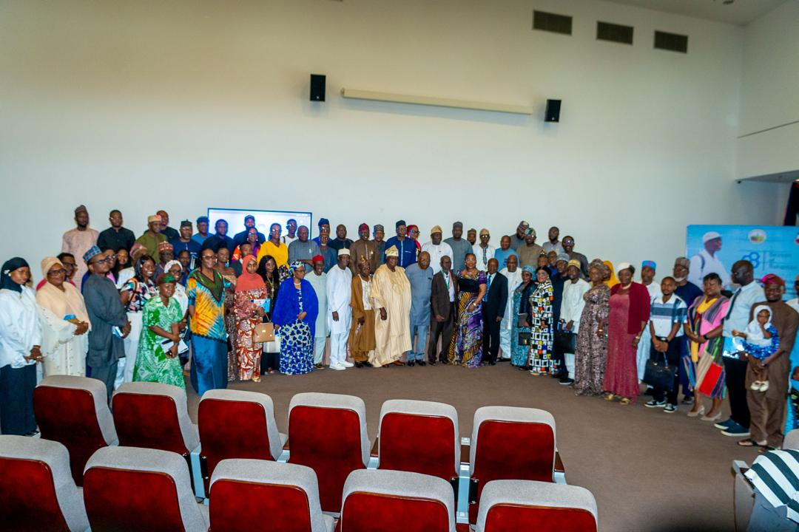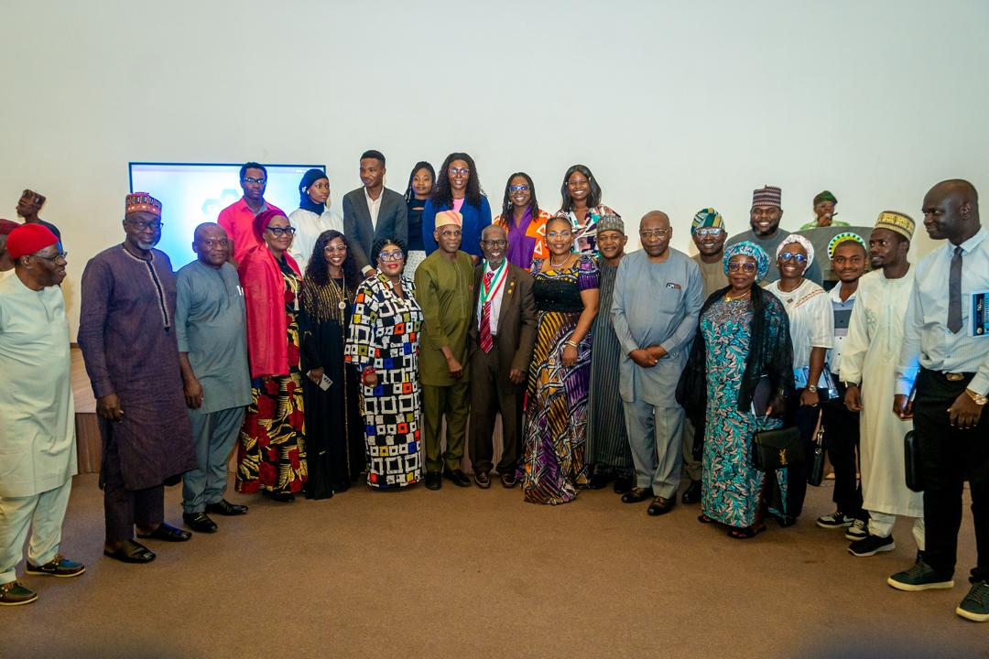
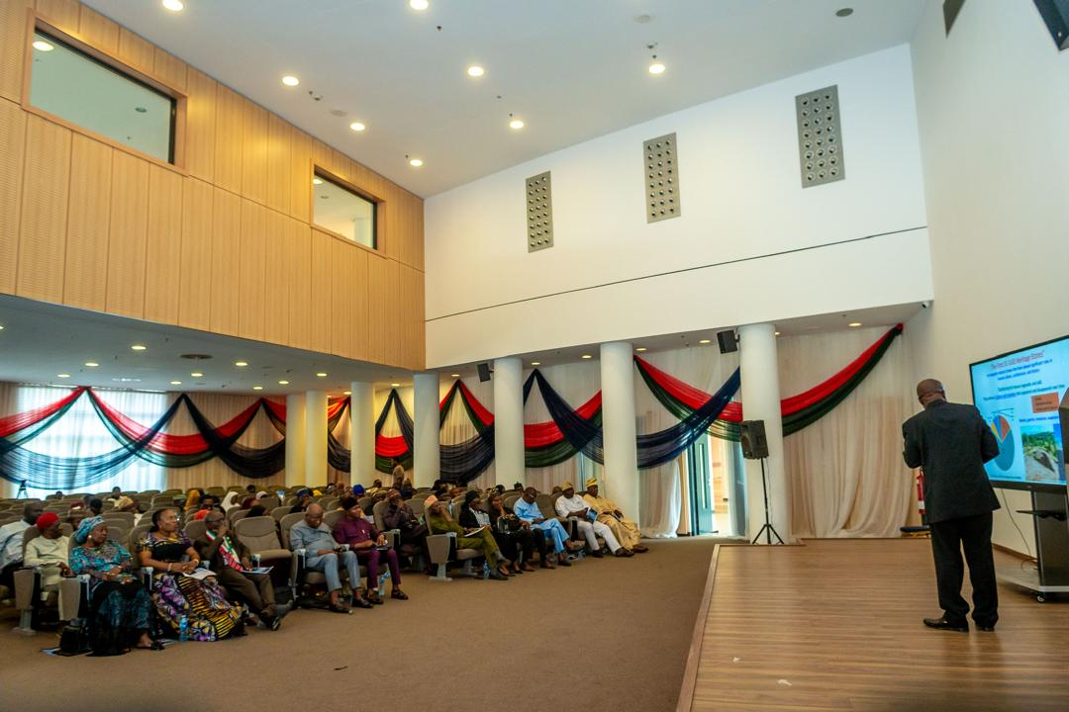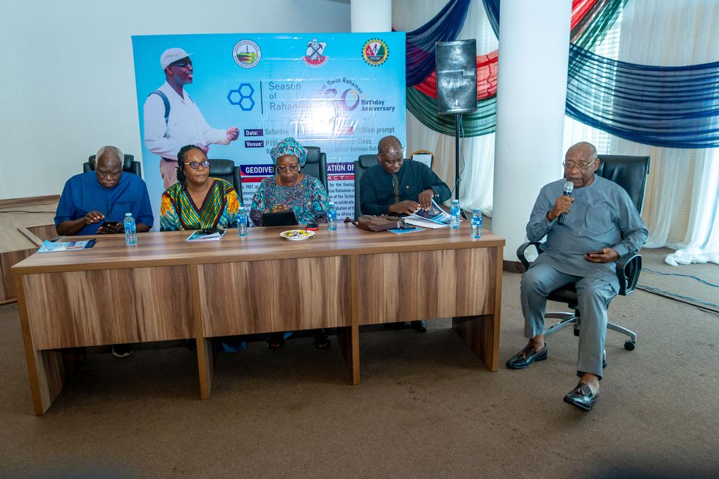
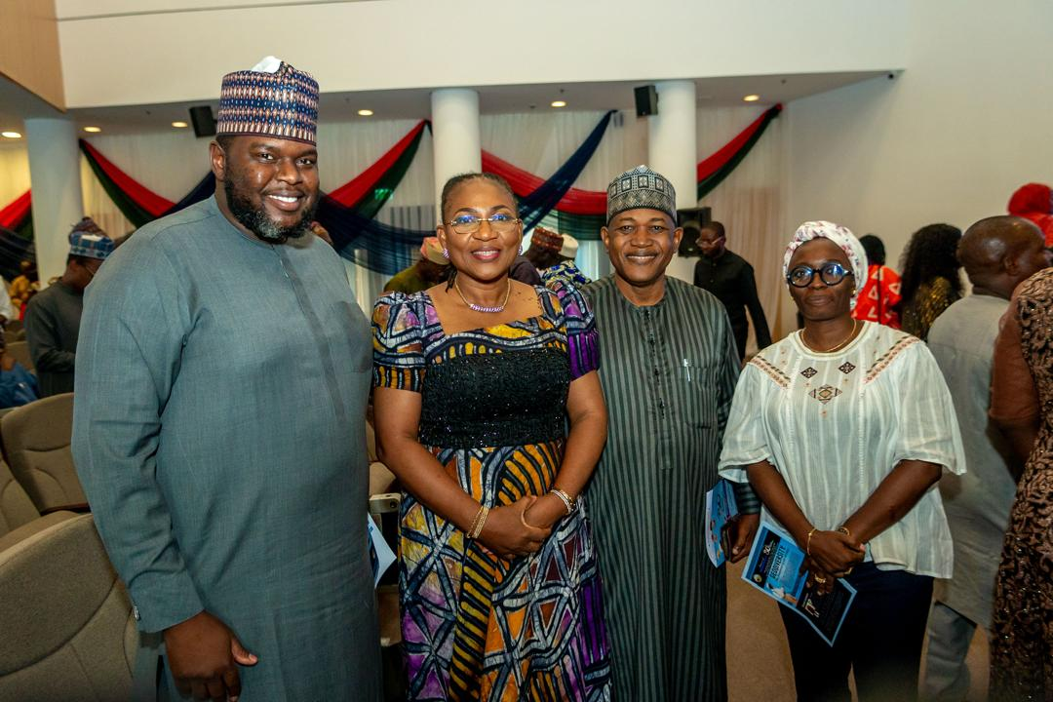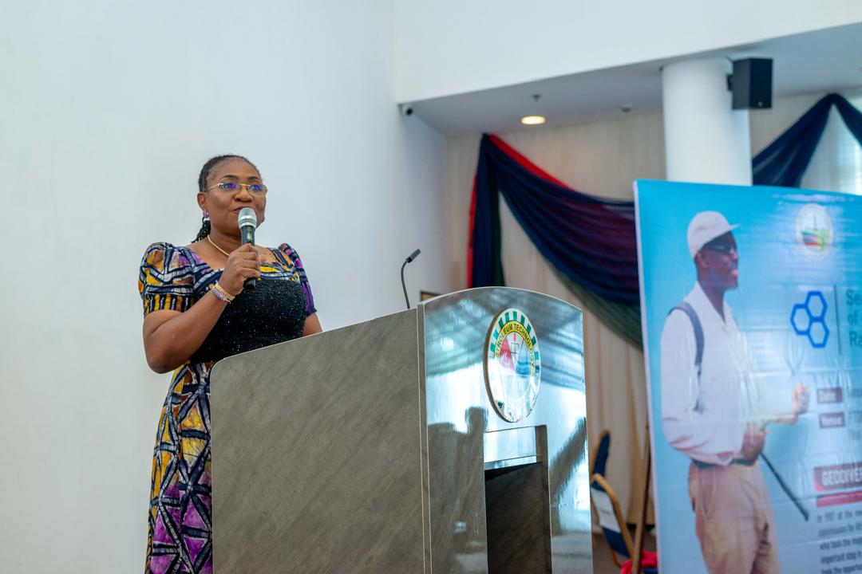
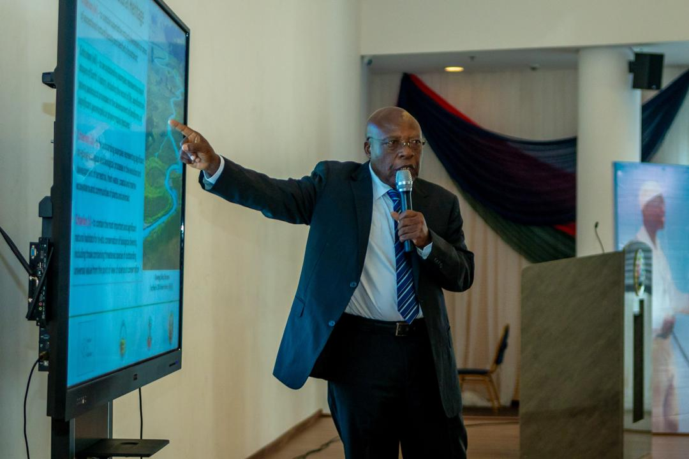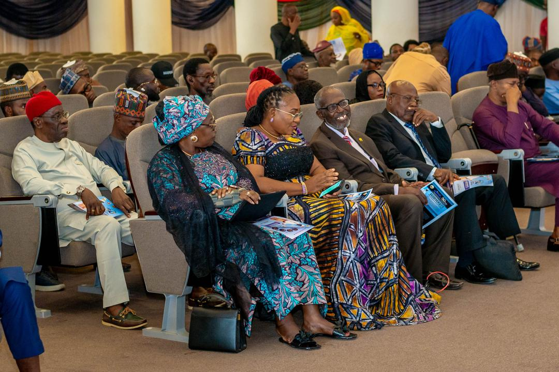

- Member Engagement Initiatives
Start Date: February 2026 (Ongoing)
Mode: Virtual (WhatsApp & Slido) with Physical Integration
In line with its commitment to continuous learning and active member participation, the Abuja Chapter introduced a series of Member Engagement Initiatives designed to foster knowledge sharing, interaction, and professional development in an engaging and accessible format.
One of the key initiatives is the Monthly Knowledge Quiz, conducted every Friday via the Chapter’s WhatsApp platform using Slido. The quiz features geology and geoscience-related questions and follows a structured qualification process, from the top 15 to top 10, and then top 5 participants, over four consecutive Fridays. The final round produces the top 3 winners, who are recognized and awarded during the Chapter’s Physical Technical Business Meetings. This initiative has recorded strong participation and has encouraged healthy competition and continuous technical learning among members.
Complementing this is the Monday Morning Fun Facts Initiative, where short, engaging, and educational facts are shared weekly on the Chapter’s WhatsApp platform. These cover diverse topics including geology, the Niger Delta, geoscience concepts, and broader energy industry insights. The initiative serves as a light but impactful way to stimulate interest, spark discussions, and keep members consistently engaged.
Together, these initiatives have significantly enhanced interaction within the Chapter, creating a vibrant and knowledge-driven community beyond formal events.
Key Outcome: Sustained member engagement, improved knowledge retention, and strengthened sense of community through interactive and continuous learning platforms.
