NAPE WARRI CHAPTER FIRST QUARTER REPORT 2026
NAPE Warri Chapter held its first Technical/Business meeting on Friday, 27th February 2026, via Zoom. It was a virtual event. The presenter was Mrs. Victoria Okorie Chevron Nigeria Limited. The presentation was Managing Subsurface Uncertainty: What Really Drives Exploration and Development Success. The Technical Business Meeting (TBM) was chaired by Mr. Ena Agbro, Chief Operating Officer Multisub Energy Limited. The TBM was sponsored by Multisub Energy, and it was well attended with 70 participants, including professionals, Academia, Young Professionals, and students.
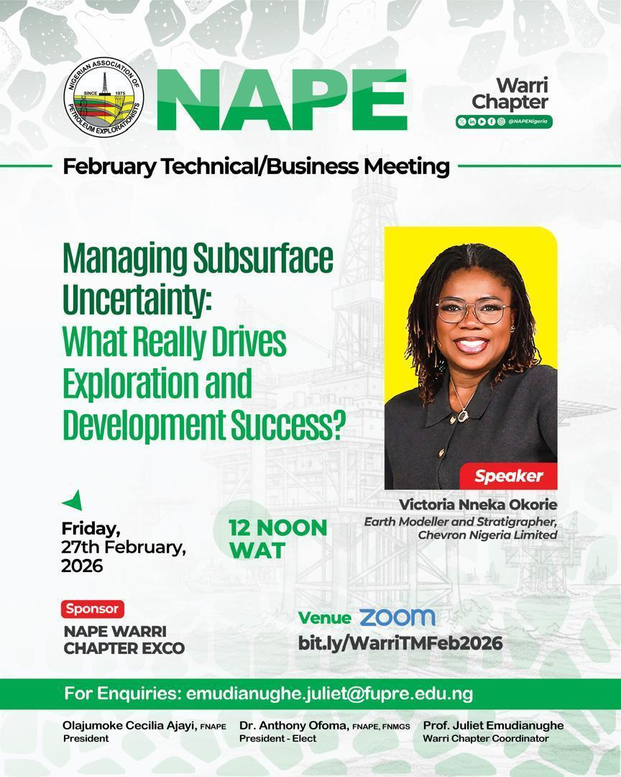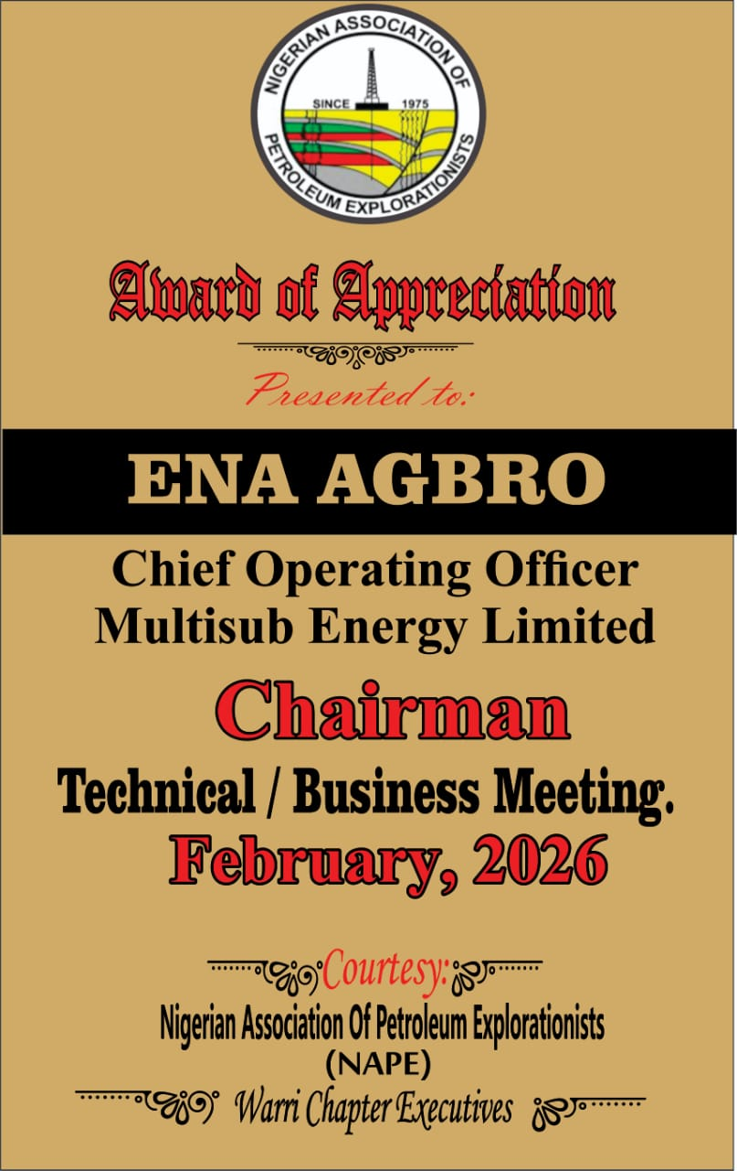
Figure 1: Flyer for February TM Figure 2: Plaque presentation to Feb Tm sponsor
Figure 2: Plaque presentation to Presenter for February 27, 2026
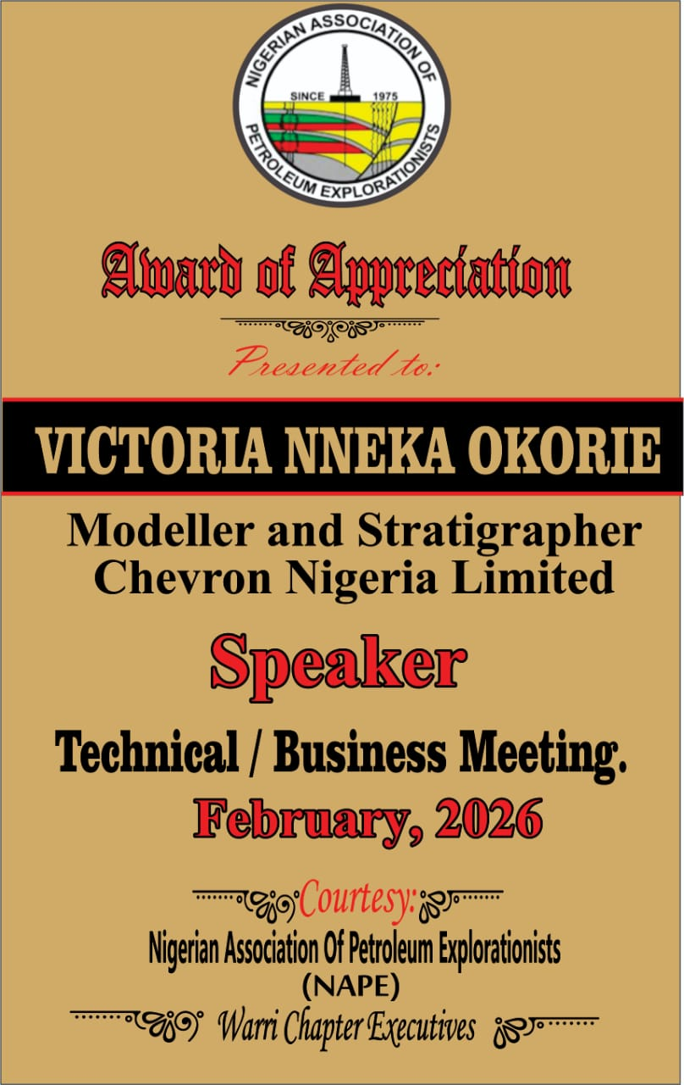

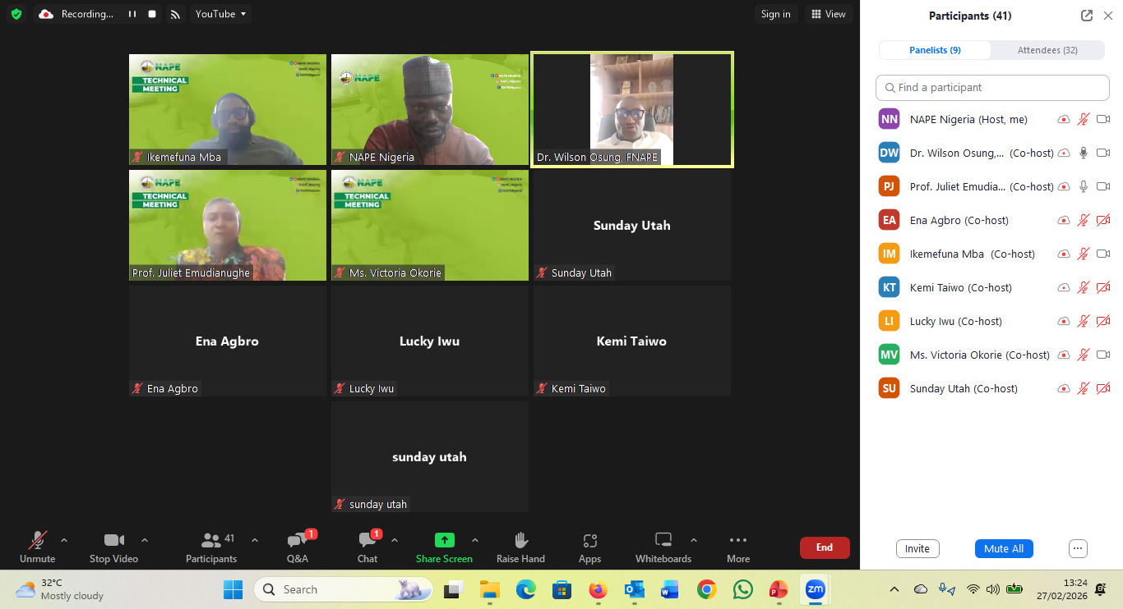
Figure 4: Audience, Feb TM

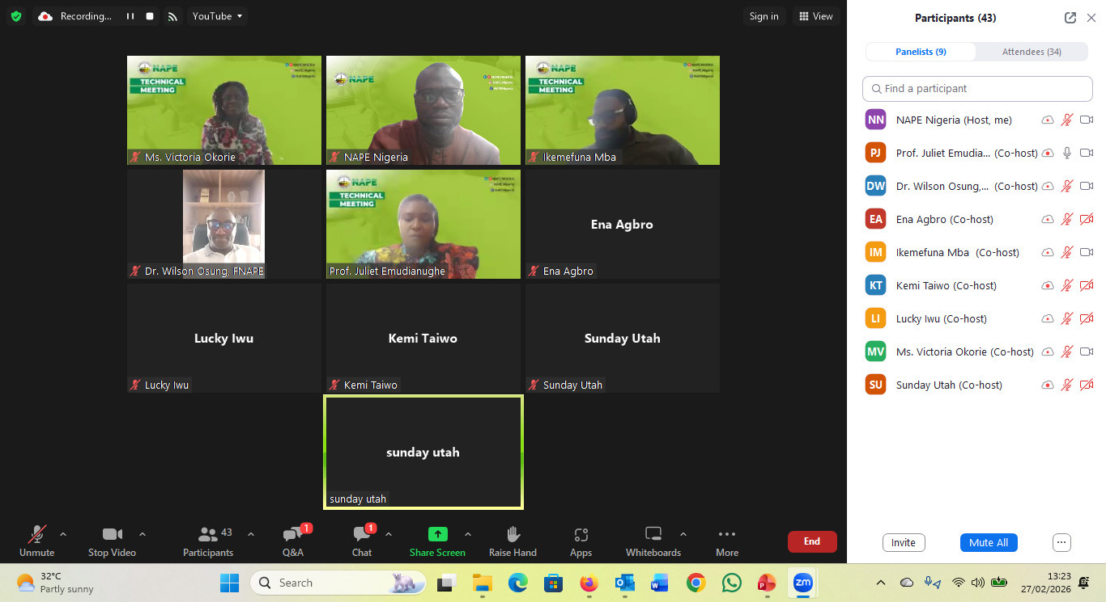
Figure 5: Audience Feb Tm

NAPE Warri Chapter held its second Technical/Business meeting on Monday, 23rd March 2026, via Zoom. It was virtual. The presenter was Engr. Chukwuebuka Kizito Duru, who presented on the black box: leveraging physics-informed machine learning for enhanced reservoir simulation and history matching. Dr. Charles Otoghile FNAPE Senior Account Manager SLB chaired the Session.
The Technical /Business Meeting was sponsored by NAPE Warri Exco Chapter. It was well attended with about 65 participants of professionals, Academia, Young Professionals, and students.
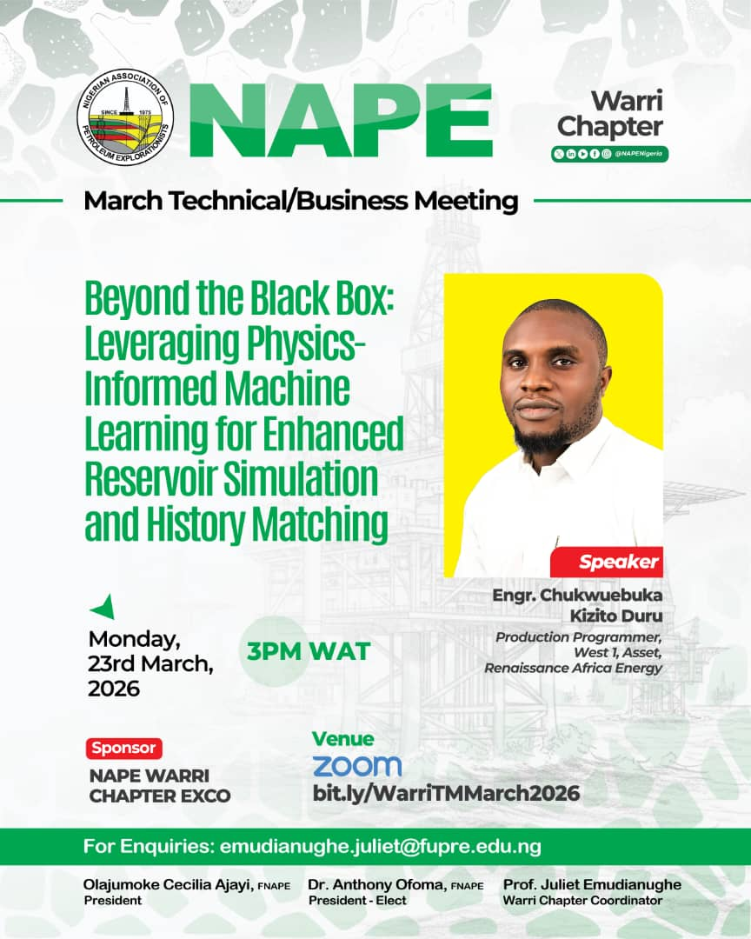
Figure 6: Flyer for March TM
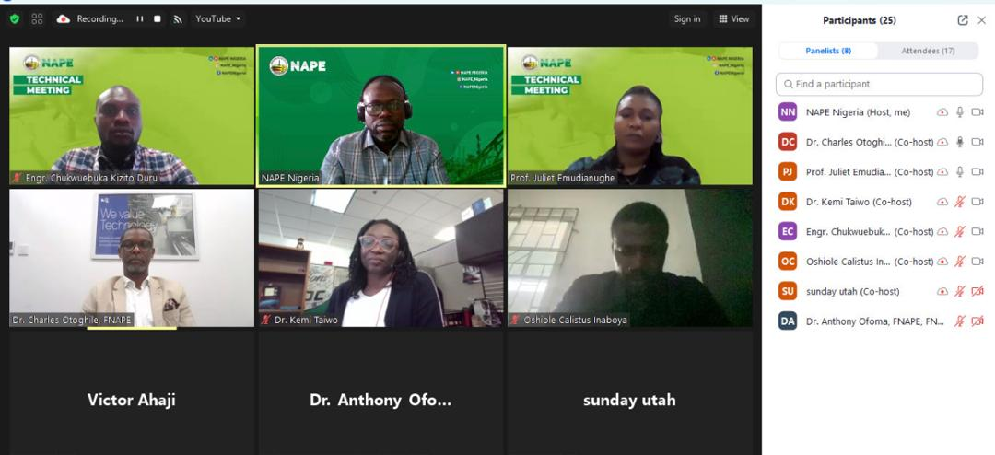
Figure 7: Cross Section of Virtual audience for March TM

NAPE Warri Chapter held its third Technical/Business meeting on Tuesday, April 7, 2025, via Zoom. It was both virtual and physical. The presenters were Ayo Mustapha, MBA MCASAE CEO Bizday Technology Consulting Limited and Bgoedov Danill, Head of AI R&D Geoplat AI, they presented on AI-Driven tectonic modelling for complex fault networks: overcoming seismic imaging challenges. NAPE Secretary Dr. Christopher Jackson FNAPE chaired the Session.
The Technical /Business Meeting was sponsored by Bizday Technology limited. It was well attended with about 210 participants (both physical and virtual) of professionals, Academia, Young Professionals, and students.
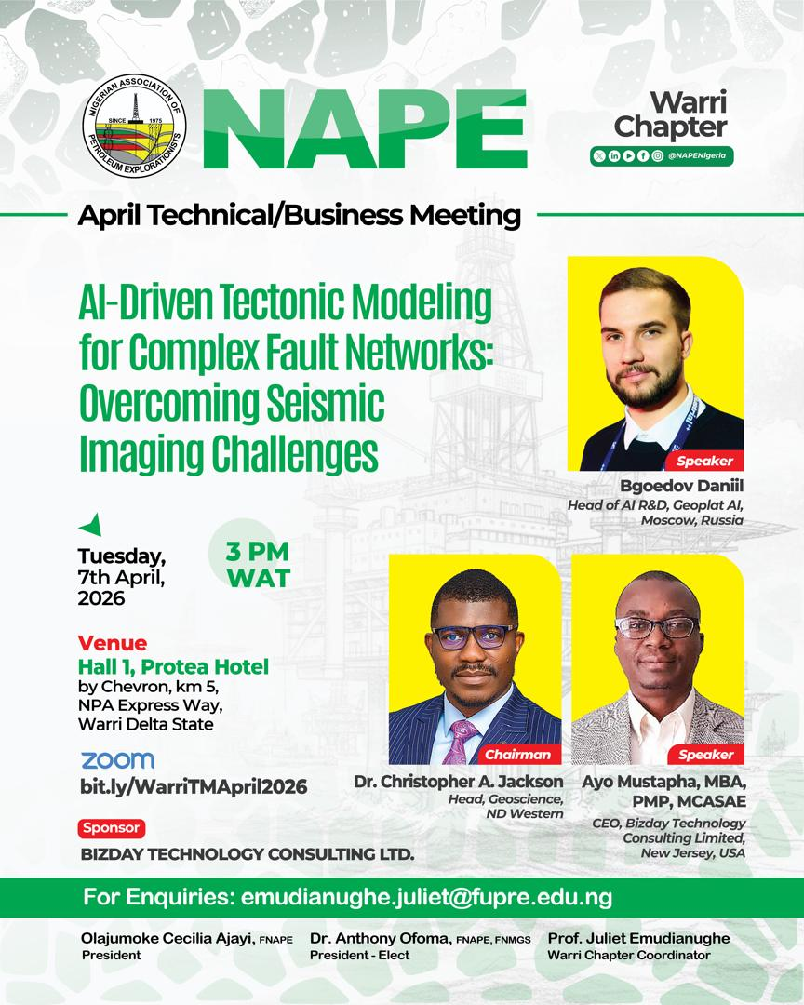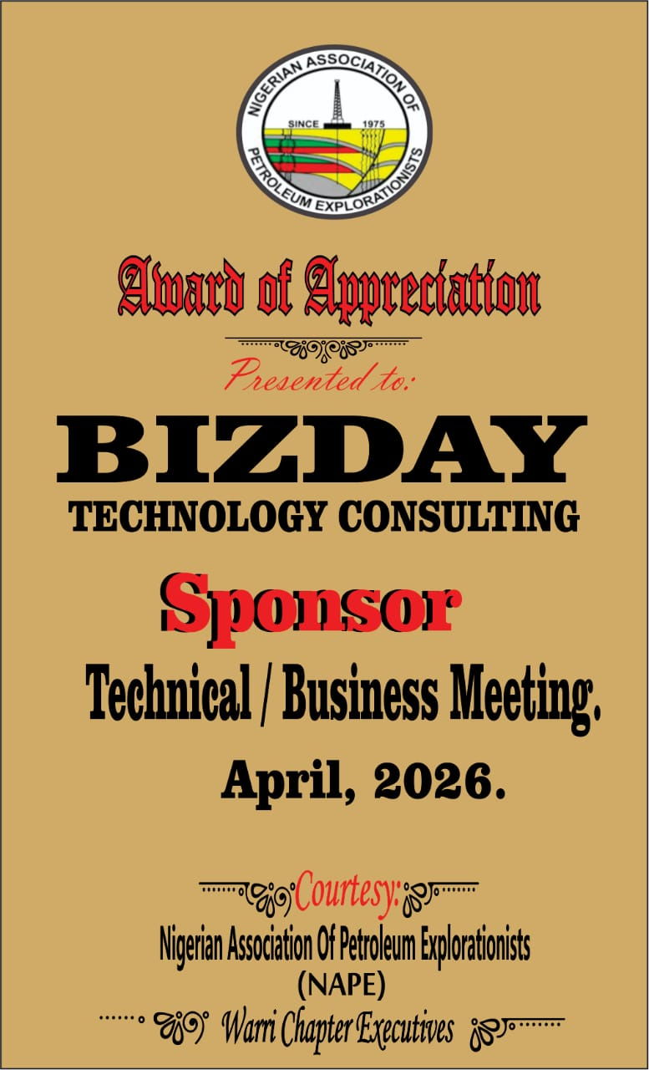
Figure 7: Flyer for April TM Figure 8: Plaque presentation to Sponsor for April 7, 2026
Figure 9: Plaque presentation to Presenters for April 7, 2026
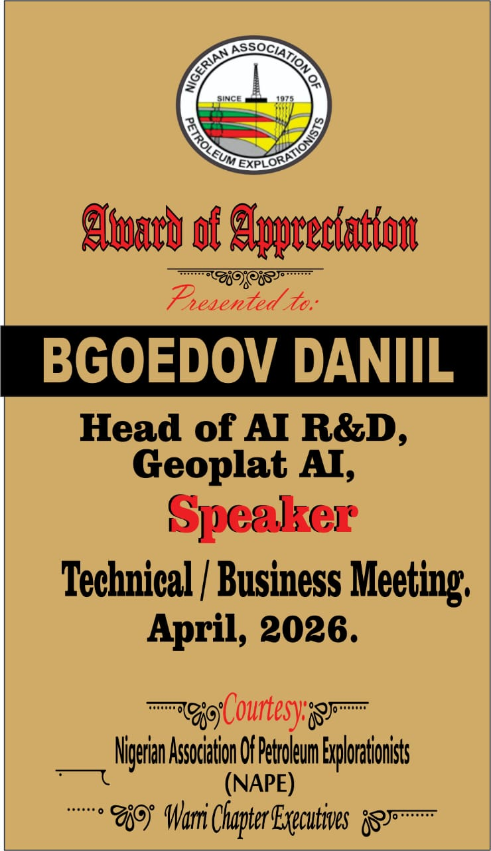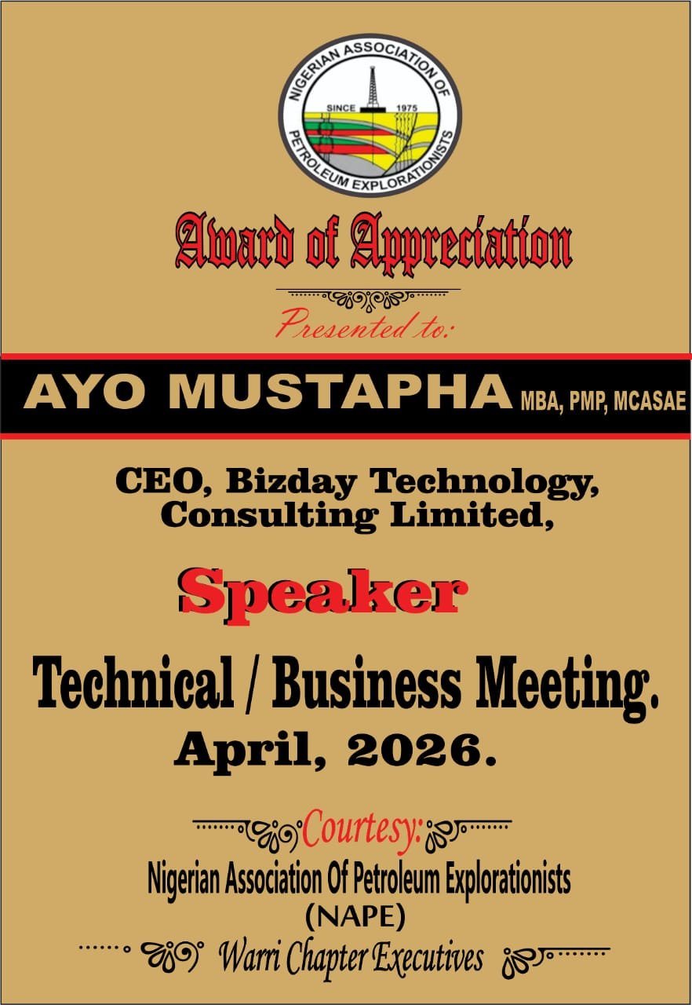
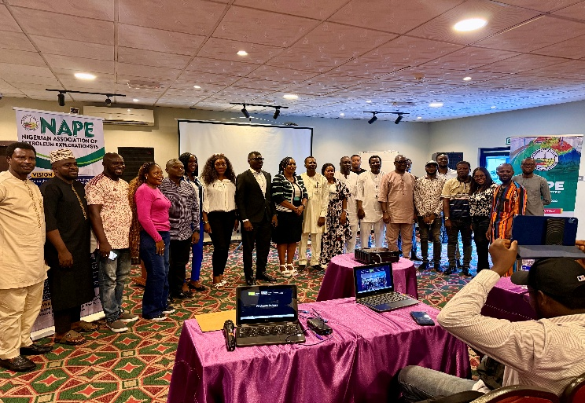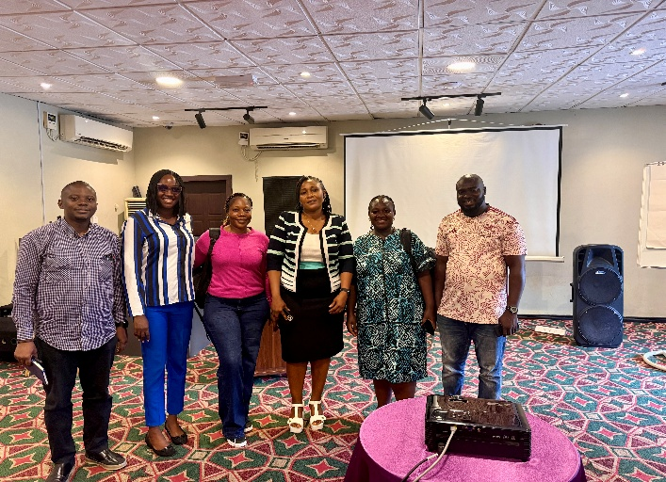
Figure 10: Cross section of attendees Online and Physical
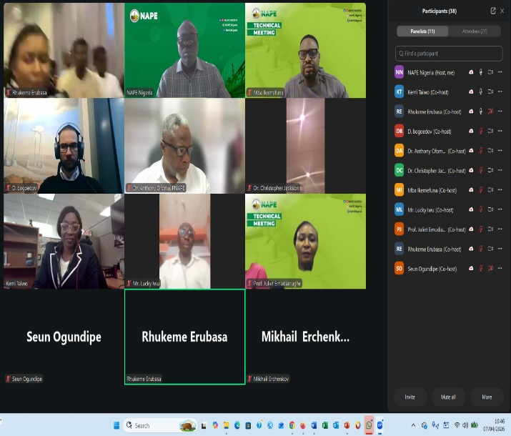

NAPE WARRI OUTREACH PROGRAMME
The Outreach was carried out on March 10, 2026. The programme was centered around sensitization about geoscience field and NAPE, Petroleum Evolution and occurrence within a reservoir and Establishment of a NAPE Club. Two schools were visited during the programme; Iterigbe Secondary school and Benetek International School that recorded an attendance of 55 and 75 persons respectively.
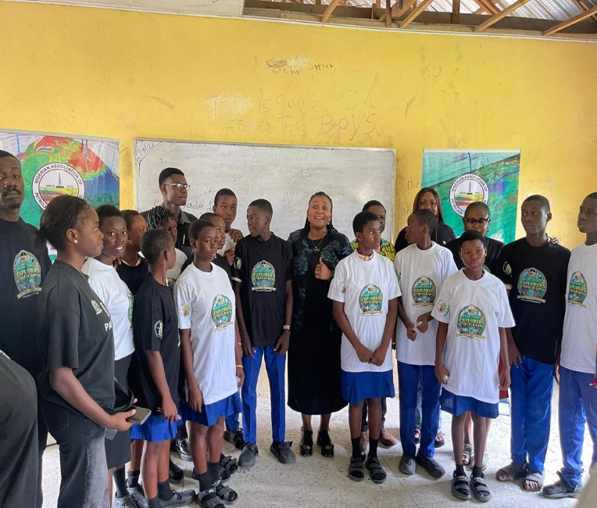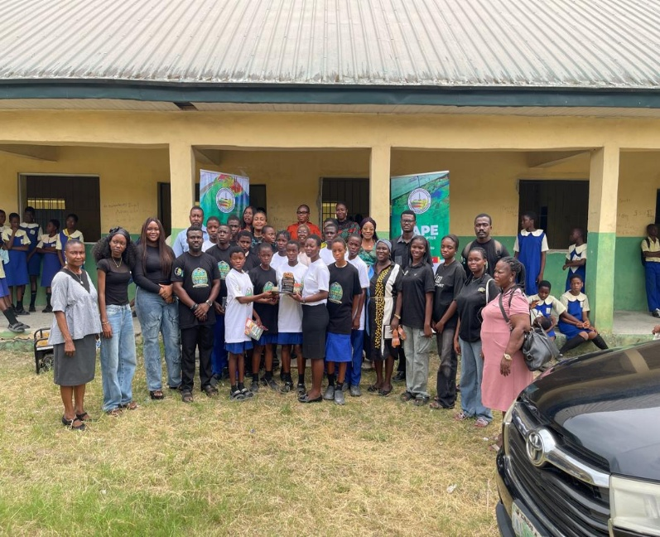
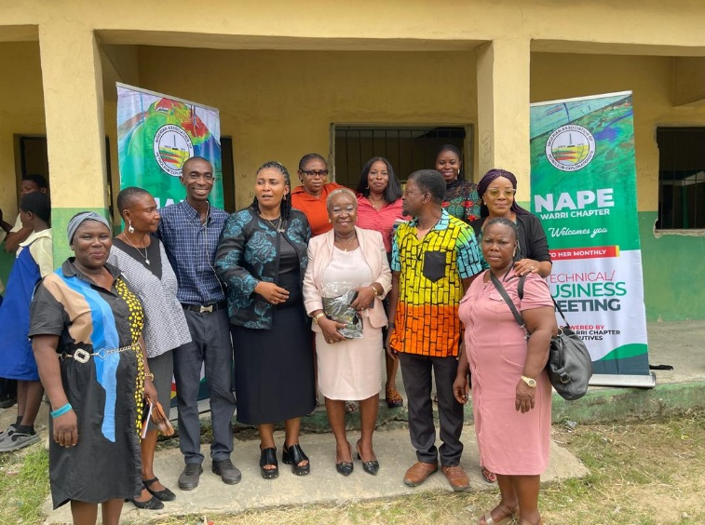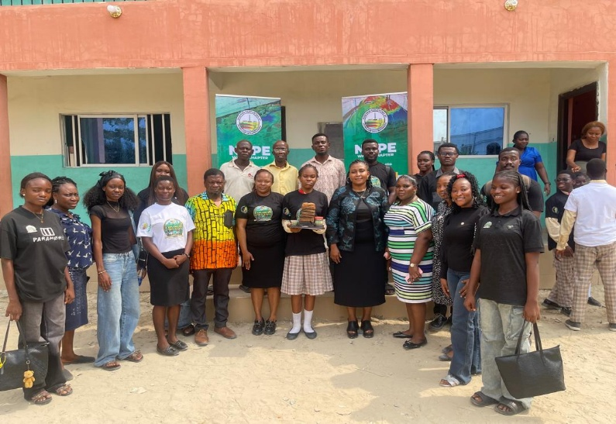
Fig 11: Cross Section of Pictures from the Outreach

TABLE: SUMMARY OF WARRI CHAPTER ACTIVITIES FOR FIRST QUARTER FOR 2026
S/N | DATE | SPONSOR | ATTENDANCE | TOPIC | SPEAKER | CHAIRMAN
1 | 22ndFeb.  2026 | NAPE Warri Chapter | 70 | Managing Subsurface Uncertainty: What Really Drives Exploration and Development Success | Victoria Nneka Okorie | Mr. Ena Agbro
2 | 23rd  March,  2026 | NAPE  Warri  Chapter | 65 | The black box: leveraging physics-informed machine learning for enhanced reservoir simulation and history matching. | Engr. Chukwuebuka Kizito Duru | Dr. Charles Otoghile FNAPE Senior Account Manager SLB
3 | 7th  April  2026 | NAPE Warri | 210 (150 – physical and 60 – virtual) | AI-Driven tectonic modelling for complex fault networks: overcoming seismic imaging challenges. | Ayo Mustapha, MBA MCASAE CEO Bizday Technology Consulting Limited and Bgoedov Danill, Head of AI R&D Geoplat AI | Dr. Christopher  Jackson, FNAPE NAPE Secretary

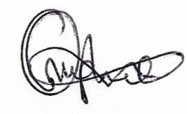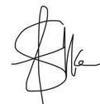
-------------------------------------- ----------------------- -----------------------
Prof. (Mrs.) J.E. Emudianughe
Warri Chapter Coordinator General Secretary Financial Secretary

