NIGERIAN ASSOCIATION OF PETROLEUM EXPLORATIONISTS (NAPE)
BENIN CHAPTER
FIRST QUARTER (Q1) REPORT – JANUARY TO MARCH 2026

1. Introduction
The first quarter of 2026 marked a significant transition and strong operational start for the NAPE Benin Chapter. The period was characterized by leadership renewal, active technical engagement, and deliberate efforts toward membership growth and strategic positioning within the broader NAPE community.
This report highlights key activities, achievements, and forward-looking plans undertaken by the Chapter between January and March 2026.

2. Key Activities and Events
2.1 Handover and Swearing-in Ceremony of New Executives
The Chapter successfully conducted its Handover and Swearing-in Ceremony on 5th January 2026 at the NNPC Staff Club House, Benin City.
The event marked the official inauguration of the newly elected executives and was graced by the esteemed President-Elect, Anthony Ofoma, FNAPE, FNMGS, whose presence underscored the importance of the occasion.
All newly elected executives were formally sworn into office, signaling the commencement of a new administrative tenure for the Chapter.
In addition, a by-election for the position of Public Secretary was conducted during the event. Mr. Dumome Macauley Abiori emerged as the winner, completing the executive structure of the Chapter.
The ceremony was well attended and provided a platform for reinforcing the Chapter’s commitment to excellence, continuity, and growth.



2.2 Maiden 2026 Business/Technical Meeting
The Chapter held its maiden Business/Technical Meeting for 2026, which recorded an impressive turnout and strong engagement from members and industry professionals.
The presentation was titled:
“Beyond Hydrocarbons: Integrated Subsurface Evaluation of Geothermal Resources and Lessons for Sedimentary Basin Development in Nigeria”
The session was delivered by Mr. Osayamen Julius Imarhiagbe, who provided insightful perspectives on diversifying subsurface resource evaluation beyond traditional hydrocarbon exploration. The event was chaired by Dr. Victor U.K. Ogunjiofor FNAPE, Manager, Well Engineering, NEPL.
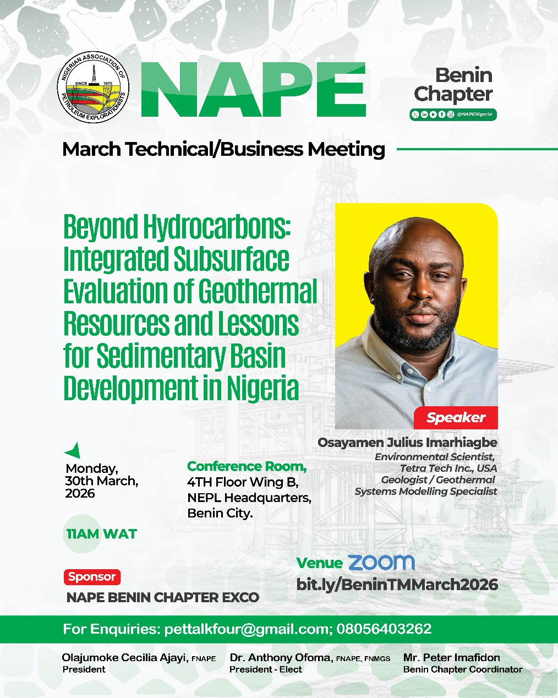
The event witnessed a total attendance of 189 participants, reflecting the Chapter’s growing influence and the high level of interest in emerging energy themes.
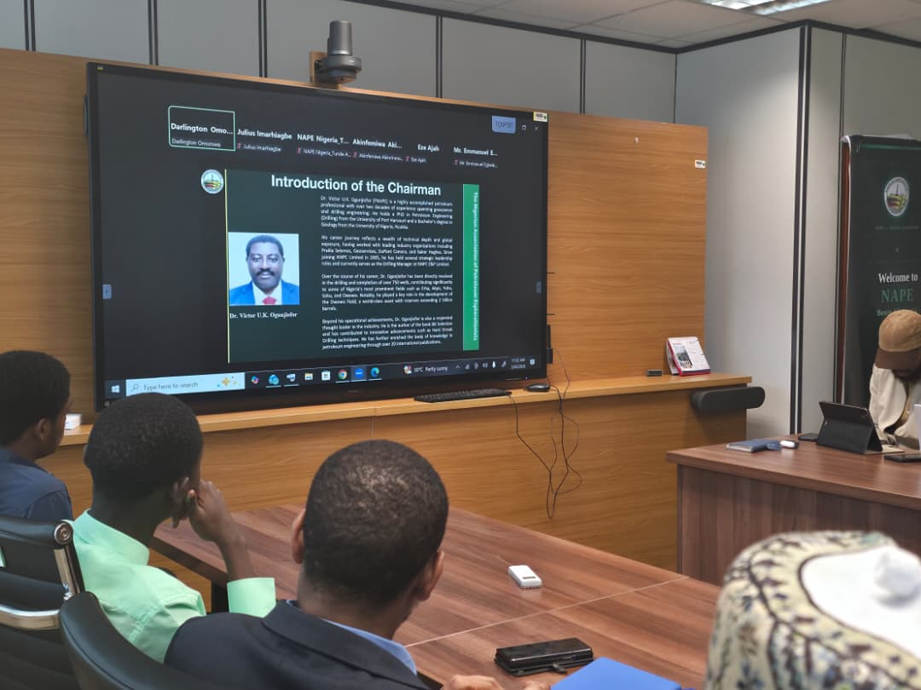
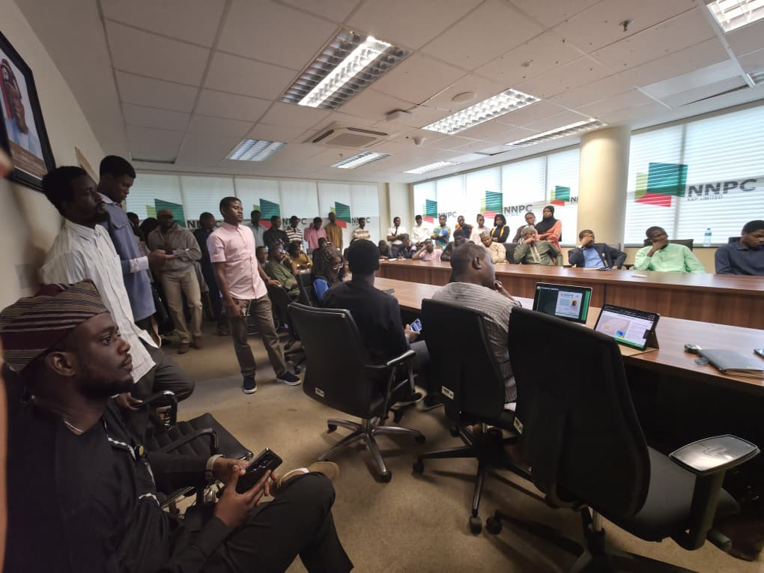
Fig-2 Audience actively listening to the Speaker’s Presentation
Fig-1 Introducing the Chairman, Dr. Victor Ogujiofor FNAPE
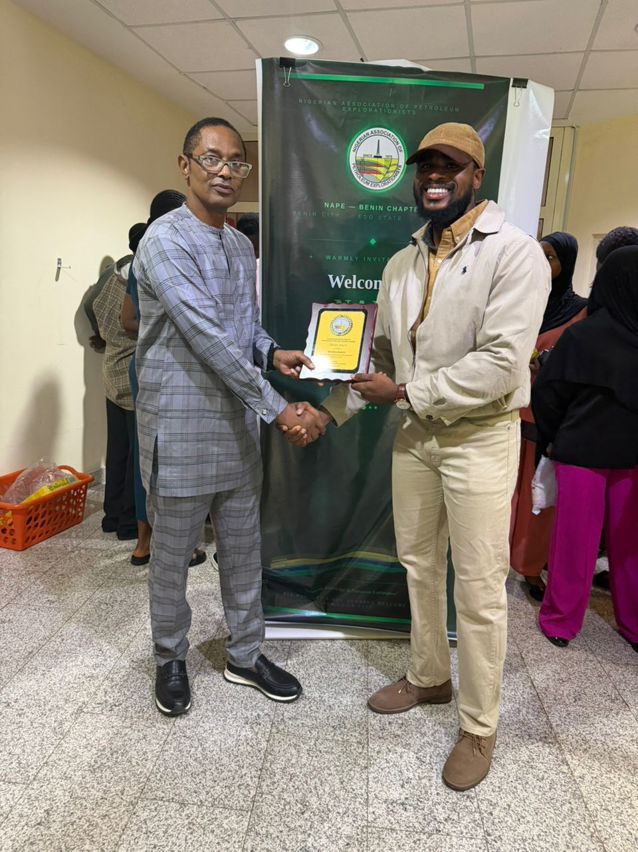

Fig-3 Award Plaque presented by the Immediate Past Chapter Coordinator, Mr. Edward Ozah to the Chairman, ably represented by the Deputy Chapter Coordinator, Mr. Stephen Tsaku
Fig-4 Award Plaque presented by the Chapter Coordinator, Mr. Peter Imafidon to the Speaker, ably represented by the General Secretary, Darlington Omorowa

2.3 Membership Drive
The Benin Chapter recorded significant growth in its membership base during the quarter.
Through a sustained and aggressive membership drive initiative, the Chapter successfully onboarded 17 new members.
This growth highlights increasing interest in the Chapter’s activities and reinforces its relevance as a hub for petroleum and energy professionals in the region.

2.4 Sponsorship Efforts for the 44th NAPE Annual International Conference and Exhibition (AICE)
Following the communication received from NAPE National regarding sponsorship for the 44th NAPE Annual International Conference and Exhibition (AICE), the Benin Chapter has been actively engaging with NEPL to secure sponsorship support.
The Chapter has maintained consistent follow-up on the required documentation, which is currently under review and progressing through the necessary approval channels.
Efforts remain ongoing to ensure timely approval and participation in this flagship event.

3. Summary of Achievements
- Successful transition of leadership through a well-organized swearing-in ceremony
- Completion of executive structure via by-election
- High-impact technical session with strong attendance (189 participants)
- Membership growth with 17 new members added
- Active engagement toward securing sponsorship for AICE

4. Outlook and Planned Activities for Q2 2026
The Chapter remains focused on consolidating its gains and expanding its impact in the coming quarter. Key priorities include:
- Sustaining the aggressive membership drive to further expand the Chapter’s base
- Hosting the second Business/Technical Meeting in May 2026
- Securing approval from NEPL for sponsorship of the 44th NAPE Annual International Conference and Exhibition (AICE)s
- Strengthening stakeholder engagement and industry collaborations

6. Conclusion
The first quarter of 2026 has positioned the NAPE Benin Chapter on a strong footing, with clear evidence of organizational vitality, member engagement, and strategic intent.
With continued commitment from the executive team and members, the Chapter is well poised to achieve even greater milestones in subsequent quarters.

Submitted by:
NAPE Benin Chapter Executive Committee
Date: April 2026

